**PROJECT TITLE**: KIBABII MISSING MARK MANAGEMENT SYSTEM

**FACULTY:** SCHOOL OF COMPUTING AND INFORMATICS (SCAI)

**Declaration**

We declare that this is work was done by group nine member and is therefore our original work.

Name ……………………………………………….. Sign ………………… Date ………….

Name ……………………………………………….. Sign ………………… Date ………….

Name ……………………………………………….. Sign ………………… Date ………….

Name ……………………………………………….. Sign ………………… Date ………….

Name ……………………………………………….. Sign ………………… Date ………….

Name ……………………………………………….. Sign ………………… Date ………….

Name ……………………………………………….. Sign ………………… Date ………….

**SUPERVISOR**

We hereby certify that this is a true dissertation for the project undertaken by the above-named students (group nine member) under my supervision and that it has been submitted to Kibabii University with our approval.

Name ……………………………………………….. Sign ………………… Date ………….

# **ACKNOWLEDGEMENT**

We would like to thank God for the continuous grace during the period we were doing the project. Our sincere gratitude goes to our supervisors who equipped us with the knowledge on how to do the project. We greatly appreciate each member for his contribution in conceptualizing, implementing and testing of the project. Also we thank all the other groups and individuals who guided us and assisted when coming up with this project.

# **ABSTRACT**

This project is aimed at managing missing marks in varsities. It help to keep track of all the students details including their names, RegNo, faculty, the unit and the corresponding lecturer for the same unit. Information will be kept in a standard manner in order to ensure that students’ marks are captured easily and effectively. This is because technology is growing rapidly and therefore a suitable mechanism need to be established to help keep the information. This system will therefore enable the storage of the information.

**SUMMARY**

Chapter one briefly describes the current system and the ideology leading to the development of the proposed system. It thus covers the scope of the project, problem definition, problem justification, feasibility study and the methods used to collect the required data.

The second chapter captures the analysis of the data and requirements. It briefly describes the methodology used to develop the system, the system requirements, functional and non-functional requirements and requirement specifications.

The third chapter the system designs. This includes the architectural design, interface design, and the data structure design. This chapter describes data flow and processing within the system and the interfaces used by the user to enter data and submit to the database.

The forth chapter talks about the system implementation. This entails coding of the system, testing it and training.

Chapter five covers the achievements made, the shortcomings encountered and recommendations for future work.

# **Table of content**

**Contents**

**ACKNOWLEDGEMENT** 2

**ABSTRACT** 3

**Table of content** 4

**Scope of the project** 7

**Economic feasibility** 8

**Technical feasibility** 9

**Operational feasibility** 9

**SYSTEM ANALYSIS** 11

**Methodology** 11

**Software development methodology** 11

**Requirements analysis** 13

**Functional requirements** 13

**SYSTEM SPECIFICATIONS** 14

**Hardware requirements:** 14

**Software requirements:** 14

**Languages and Technologies used:** 15

**CHAPTER 3** 15

**System Design and Architecture** 15

**Database Design** 15

20

**Conceptual Design** 20

**Interface Design** 21

22

**CHAPTER FOUR** 27

**SYSTEM IMPLEMENTATION AND TESTING** 27

**Coding** 27

**Testing** 31

**Functional testing** 31

**Structural testing** 32

**Unit testing** 32

**CHAPTER FIVE** 33

**RECOMMENDATIONS** 33

**SHORTCOMMINGS** 33

**CONCLUSION** 33

**1.1CHAPTER ONE**

**BACKGROUND INFORMATION**

**1. 3 Introduction**

The honor of a university is reducible to a how a single grade is individually and institutionally processed.

A grade is the currency of academic mobility and one of only a few indicators of merit and accomplishment. Grades and marks are also the only non-demonstrable material representation of intangible knowledge and skills acquired in the course of training. In the university, a singular grade is secured by a structure of boards, external examiners and senates to preserve its hallowed status. To tinker with a grade, let alone lose one, is near sacrilege. However, while the public has been quick to point an accusing finger at academics over missing marks, what has been lost in the entire debate is that missing marks are merely symptomatic of a bigger problem, both structural and moral. The moral contradictions of missing marks emerge out of the larger aspects of a dysfunctional structure. Thus, missing marks are only symptoms and a proper diagnosis must go beyond them. First, missing marks are the evidence of a poverty of academic leadership for more than 10 years. From the highest offices in the Education Ministry to academic leadership in departments, the rains started beating us when we lost sight of the true meaning of higher education and its role in society and in national development. Missing marks and lost grades are the outworking of unplanned university expansions, and the exaltation of a mercantile logic into higher education. Physical and human resources The massification of higher learning came with a hefty price. While universities sought as many numbers of students as possible from a populace that is convinced that a university degree is the only gateway to improved social and economic status, this horizontal, dispersed expansion was not followed through with a proportional, vertical expansion of physical and human resources. More damning, the previous systems of organizing and processing examinations established in the 1970s and 1980s for only hundreds of students were not equipped to process the details of thousands of students today. At a political level, the populist massification of higher learning was articulated as opening spaces for other deserving Kenyans. These lofty ideals had unintended consequences. Universities slowly lost control of their own academic calendars. More troubling, the pressure to keep up a continuous calendar sacrificed a revered academic culture; that students must of necessity publish results of the previous academic year before proceeding to the next. This is not only sensible, but is paramount in a system anchored on progressive learning. As I write, few universities have functional almanacs beyond an academic year. As such, with crucial decisions on term dates in disarray, and academic timelines made whimsically, academics and students often struggle to manage their own and institutional timelines of managing exams. The compounded problem thus affects an examination process that should ideally be predictable and simple. Only a structured, simple and predictable examination process can rid our universities of missing marks. This process must be guided by strict guidelines, timelines and clear procedures on the obligations of students and academics within this process.

## **1. 2 Scope of the project**

The proposed system is capable of performing registration for students and the lecturers, where the system user or department staff in Administration Department who will be in charge of managing the marks at the departmental level. This system is responsible for managing the missing mark registration process that includes information of the students and the lecturer including the student’s regNo, Name, faculty and the marks missing of the unit. The lecturers name and phone number will also be captured. Besides, the system is responsible for managing the login and logout function for the user who uses this system.

The proposed system is also be limited to the area of adding, editing and deleting the corresponding information of the system users.

**1.3 Statement of the problem**

From time to time, a Board of Examiners may have to consider reaching decisions based on an incomplete set of marks. This may apply to an individual student who has missed assessment through illness, incomplete fees in which case it will be processed through a Special Considerations Board. Alternatively, it can occur when a set of assignments, marks or scripts are not available or have been lost due to fire, theft, accident, absence of examiner, loss, industrial action, or other possible similar causes. This therefore implies that for one to trace his/her missing mark, one has to follow set of procedures in order to be succseful.Also a lot of paper work is done through the process and this may somehow lead to the misplacement of such forms. In most cases the lecturer might be a part timer and therefore tracing such persons in time of need might be tiresome. Therefore Considerations may then apply to a group of students, and will be processed through the main Board of Examiners.

Therefore the proposed system will address such issues and finally find long lasting solutions.

**1.4 Problem justification**

From time to time, a Board of Examiners may have to consider reaching decisions based on an incomplete set of marks. This may apply to an individual student who has missed assessment through illness, etc., in which case it will be processed through a Special Considerations Board. Alternatively, it can also occur when a set of assignments, marks or scripts are not available or have been lost due to fire, theft, accident, absence of examiner, loss, industrial action, or other possible similar causes. Considerations then apply to a group of students, and will be processed through the main Board of Examiners.

This is why the proposed Kibabii University Management System will be of great help if implemented in the institution.

New data entry would be made much faster and more importantly, specifically each marks added into the system would be accounted for in the most organized manner.

The corresponding details of the lecturer teaching the units details will be also added, this enhances easy retrieval of the lecturer even at the student level.

**1.5.0 Feasibility Study**

This refers to the [analysis](http://www.businessdictionary.com/definition/analysis.html) and [evaluation](http://www.businessdictionary.com/definition/evaluation.html) of the proposed [project](http://www.businessdictionary.com/definition/project.html) to determine if it is technically, economically and operationally feasible. From the systems analyst perspective, the feasibility analysis is the primary tool for recommending whether to proceed to the next phase or to discontinue the project.

### **1.5.1 Economic feasibility**

Economic feasibility is the most frequently used method for evaluating the effectiveness of the system. Most commonly known as cost analysis, the procedure is to determine the benefits and savings that are expected from the Kibabii University Missing Mark Management System and compare them with the costs. If benefits outweigh the costs, then the decision is made to design and implement the system. A cost analysis was done for the proposed system to evaluate whether it would be economically viable or not**.**

### **1.5.2 Technical feasibility**

It also considers the technical requirements of the proposed system. This system addresses whether the current and available technology can support the proposed system. The technical requirements are then compared to the technical capability of the users. The developed system is flexible and easy to learn by every user within the shortest time of training today and thus the project is technically feasible.

### **1.5.3 Operational feasibility**

Operational feasibility determines the extent to which the required software performs a series of steps to solve business problems and user requirements. This feasibility is dependent on human resources (project development team) and involves visualizing whether the project will operate after it is developed and be functional once it is installed. Operational feasibility also performs the following tasks.

* Determines whether the problems anticipated in user requirements are of high priority
* Determines whether the solution suggested by the software development team is acceptable
* Determines whether the organization is satisfied by the alternative solutions proposed by the software development team.

The developed system is operational since it solves all areas of paper work and implements a totally new system.

## 1.6 System Requirements Capturing

1. **Interview**

Interviews enabled us to collect information from individuals or group of people working with the current system. The importance of this method of data collection is that the data analyst gets first-hand information from the users of the system**.**

1. **Questionnaire**

This involves open ended and closed questions to the respondents on a piece of paper. This enabled me get information about which the respondents cannot deliver verbally. Questionnaires were issued to the attendants to give their view about the working of the current system and the specifications and the function of the proposed system.

1.7 The Project Schedule

|  |  |  |  |  |  |  |  |  |  |  |  |  |
| --- | --- | --- | --- | --- | --- | --- | --- | --- | --- | --- | --- | --- |
| **Implementation period in days** | | | | | | | | | | | | |
| **Activity** | 1 | 2 | 3 | 4 | 5 | 6 | 7 | 8 | 9 | 10 | 11 | 12 |
| **Feasibility study** |  |  |  |  |  |  |  |  |  |  |  |  |
| **Analysis** |  |  |  |  |  |  |  |  |  |  |  |  |
| **Designing** |  |  |  |  |  |  |  |  |  |  |  |  |
| **Implementation** |  |  |  |  |  |  |  |  |  |  |  |  |
| **Testing** |  |  |  |  |  |  |  |  |  |  |  |  |
| **Presentation** |  |  |  |  |  |  |  |  |  |  |  |  |
| **Documentation** |  |  |  |  |  |  |  |  |  |  |  |  |

## **2.0 SYSTEM ANALYSIS**

## 2.1 Methodology

## **Methodology**

Methodology is often regarded as accepted and recommended series of steps and procedures to be followed when designers are developing an information system. System development methodology is a recommended collection of phases, rules, techniques, tools, documentation, management and training of developers for an information system development.

## 2.2 Software development methodology

**Incremental model**

Incremental development is based on the idea of developing an initial implementation, exposing this to user comment and evolving it through several versions until an adequate system has been developed validation activities are interleaved rather than separate, with rapid feedback across activities.

Incremental development reflects the way that we solve problems.

We rarely work out a complete problem solution in advance but move toward a solution in a series of steps, backtracking when we realize that we have made a mistake. By developing the software incrementally, it is cheaper and easier to make changes in the software as it is being developed.

Each increment or version of the system incorporates some of the functionality that is needed by the customer. Generally, the early increments of the system include the most important or most urgently required functionality. This means that the customer can evaluate the system at a relatively early stage in the development to see if it delivers what is required. If not, then only the current increment has to be changed and, possibly, new functionality defined for later increments. The technology used in developing this system is incremental software process model because it allows tests to be conducted at the end of each phase.

This model works well for small projects.

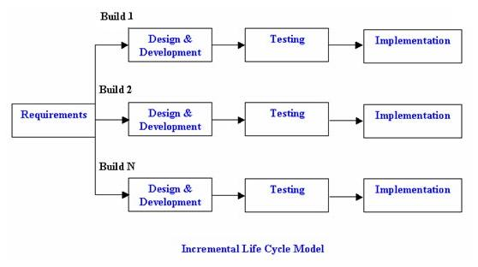

**Advantages of Incremental model:**

1. Generates working software quickly and early during the software life cycle.
2. This model is more flexible – less costly to change scope and requirements.
3. It is easier to test and debug during a smaller iteration.
4. In this model customer can respond to each built.
5. Lowers initial delivery cost.
6. Easier to manage risk because risky pieces are identified and handled during it’d iteration.

**Disadvantages of Incremental model:**

1. Needs good planning and design.
2. Needs a clear and complete definition of the whole system before it can be broken down and built incrementally.

## 2.3.0 Requirements analysis

### 2.3.1 Functional requirements

Functional requirements define the capabilities and functions that a system must be able to perform successfully. The functional requirements of the System include:

1. The system shall allow users be able to keep all the information of the users including the students and the lecturers
2. The system shall allow users be able to generate the reports of their customers, employees and vehicles
3. The system shall enable the administrator to add, delete and update students and lecturer details
4. The system shall enable the administrator to add, register, delete or update users
5. The system shall enable the users search and retrieve the information he or she wants and generate

2.3.2. Non-functional requirements

A non-functional requirement is a requirement that specifies criteria that can be used to judge the operation of a system, rather than specific behaviors’. Some of the non-functional requirements include of the system include;

1. The system will allow users full time availability.
2. The system have security features in that not anyone can access the system. To access the system one need to have a password and a username. This will help to prevent information from be accessed by unauthorized people and ensure security of the data within the system
3. The new systems will assure maintainability, in order to avoid similar issues to arise in the future
4. The system have navigation features which improves interactivity

## 2.4 SYSTEM SPECIFICATIONS

In order for the system to run effectively, the computer server system is required to meet the following specifications:

### **Hardware requirements:**

* **A Computer with the following properties;**
  1. RAM of at least 2GB
  2. A system type of about 32-bit or above
  3. Minimum processing speed of 1.6GHZ
  4. Hard disk of a round 500 GB and above.
* External hard disk of around 320gb

### **Software requirements:**

* Operating Systems: Windows 7, 8...
* WAMP Server
* Visual Studio 2012

### **Languages and Technologies used:**

* C#
* MySQL connector Net 6.6.5
* Dot net framework
* MySQL Connector/ODBC 5.1

# CHAPTER 3

## **3.0 System Design and Architecture**

## 3.0.1 Database Design

**Faculty**

Faculty_ID (pk)

Faculty_Name

Office_No

**Registration**

Reg_Id[p.k]

Reg_No[f.k]

**Student**

Reg_No (pk)

Student_Name

Phone_No

Gender

Status

Department_ID

**Course**

Course_ID (pk)

Course_Name

**Programme**

Programme_ID (pk)

Programme_Name

Department_ID (fk)

**Programme_course**

Progcourse_ID (pk)

Programme_ID (fk)

Course_ID (fk)

Semester

Year_Of_Study

**Department**

Department_ID (pk)

Department_Name

Office_No

Faculty_ID (fk)

**Lecturer**

Pf_No (pk)

Lecturer_Name

Phone_No

Department_ID (fk)

**Application**

Serial_No [P.K]

Reg_No[F.K]

Course_Id

Semester

Year_Of_Study

**Loading**

Loading_ID (pk)

Progrcourse_ID (fk)

Pf_No (fk)

**Database Screenshots**

**Application Table**

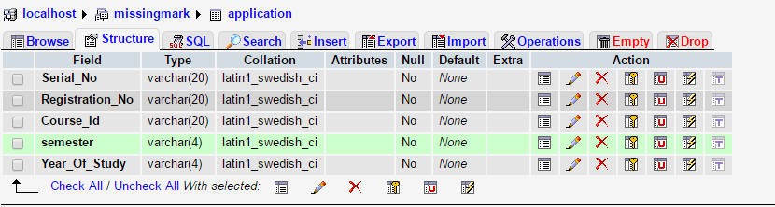

**Course Table**

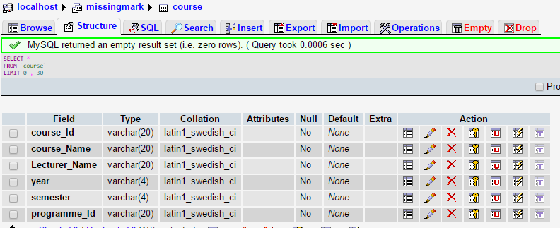

**Department Table**

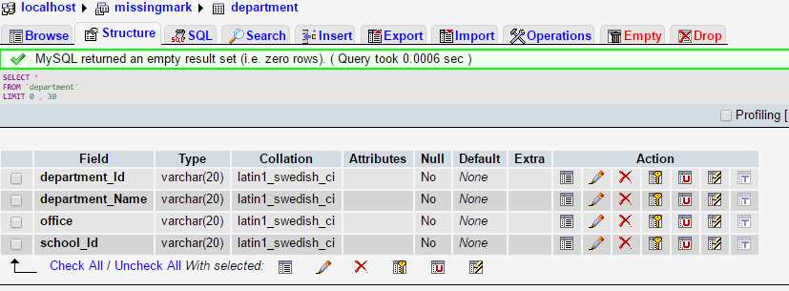

**Faculty Table**

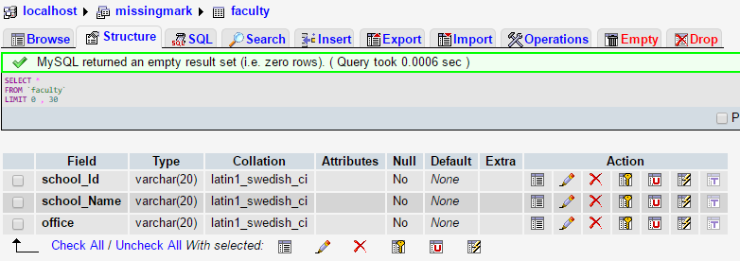

**Lecturer Table**

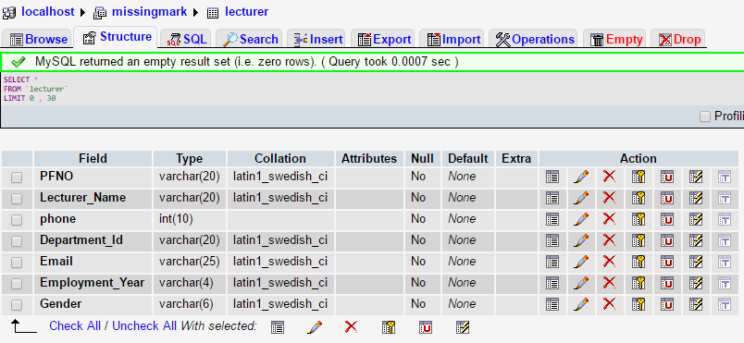

**Programme Table**

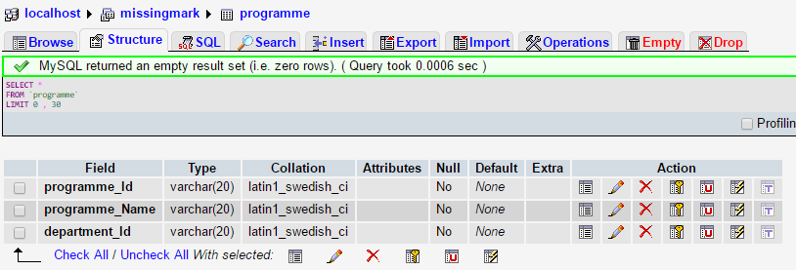

## 

Login verification

Error message

Logout

Admin

Show report

NO

YES

Login

Management

Database

Admin gives and prints reports

## **Conceptual Design**

Student, department, registration, course, faculty, programme

Login verification

Error message

Logout

Admin

Show report

NO

YES

Login

Management

Database

Admin gives and prints reports

## **Interface Design**

**Log in Interface**

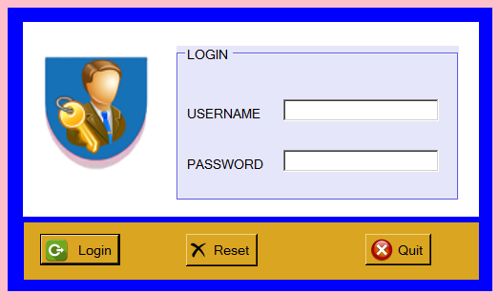

**School Interface**

## G:\stu.PNG

**Course Interface**

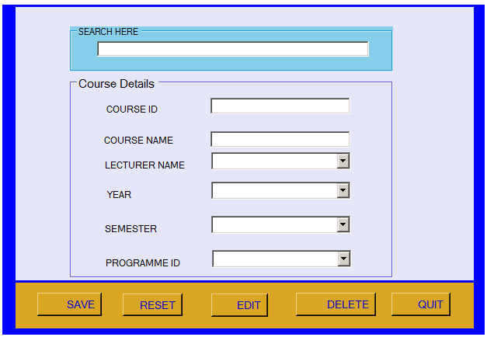

**Student Interface**

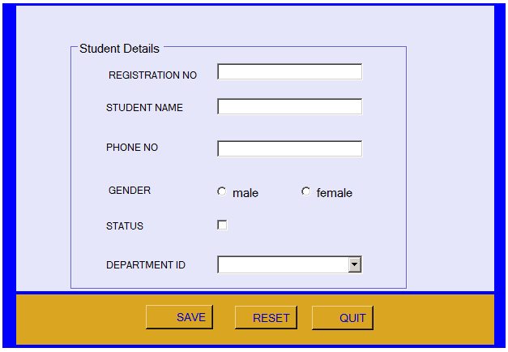

**Programme Interface**

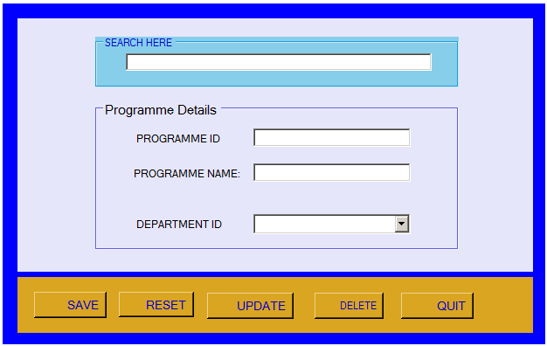

**Application Interface**

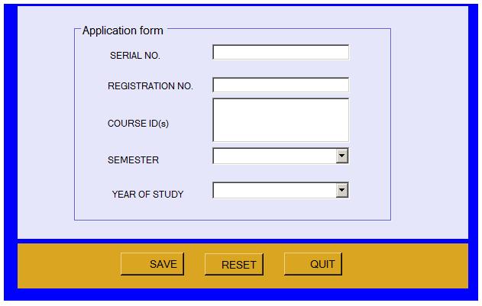

# 4. 0 CHAPTER FOUR

## **4.1 SYSTEM IMPLEMENTATION AND TESTING**

## **4.2. Coding**

Coding is a programming technique of implementing the system by choosing suitable programming language. A collection of languages have been used to develop this system, that is; PHP, JAVA SCRIPT,CSS and the database designed using MSQL.

The main coding language for our system was the **c#.**

**Sample coding**

using System;

using System.Collections.Generic;

using System;

using System.Collections.Generic;

using System.ComponentModel;

using System.Data;

using System.Drawing;

using System.Linq;

using System.Text;

using System.Threading.Tasks;

using System.Windows.Forms;

using MySql.Data.MySqlClient;

using WindowsFormsApplication1;

namespace KMMMS

{

public partial class frmlecture : Form

{

public frmlecture()

{

InitializeComponent();

}

private void comboBox1_SelectedIndexChanged(object sender, EventArgs e)

{

}

private void frmlecture_Load(object sender, EventArgs e)

{

conn cn = new conn();

string query = "";

query = "SELECT * FROM department ORDER BY department_ID ASC";

if (cn.openConnection() == true)

{

MySqlCommand cmd = new MySqlCommand(query, cn.connect);

MySqlDataReader dataReader = cmd.ExecuteReader();

this.cbodptid.Items.Clear();

while (dataReader.Read())

{

this.cbodptid.Items.Add(dataReader["department_ID"].ToString());

}

}

cn.CloseConnection();

}

private void btnQuit_Click(object sender, System.EventArgs e)

{

if (MessageBox.Show("Are you sure you want to quit?", "KUMMMS Message", MessageBoxButtons.YesNo, MessageBoxIcon.Question) == DialogResult.Yes)

{

this.Dispose();

}

}

public void Clean()

{

txTPF.Text = "";

txtname.Text = "";

txtphone.Text = "";

cbodptid.Text = "--select department--";

txtemail.Text = "";

cboemp.Text = "Select employment year";

}

private void btnReset_Click(object sender, System.EventArgs e)

{

Clean();

}

private void btnSave_Click(object sender, System.EventArgs e)

{

string gender = "";

if (rbtnmale.Checked == true)

{

gender = "male";

}

else

{

gender = "female";

}

if (txTPF.Text == "")

{

MessageBox.Show("Ensure all fieds are filled", "KUMMMS message", MessageBoxButtons.OK, MessageBoxIcon.Error);

txTPF.Focus();

}

else if (txtname.Text == "")

{

MessageBox.Show("Ensure all fieds are filled", "KUMMMS message", MessageBoxButtons.OK, MessageBoxIcon.Error);

txtname.Focus();

}

else if (txtphone.Text == "")

{

MessageBox.Show("Ensure all fieds are filled", "KUMMMS message", MessageBoxButtons.OK, MessageBoxIcon.Error);

txtphone.Focus();

}

else if (cbodptid.Text == "")

{

MessageBox.Show("Ensure all fieds are filled", "KUMMMS message", MessageBoxButtons.OK, MessageBoxIcon.Error);

cbodptid.Focus();

}

else if (txtemail.Text == "")

{

MessageBox.Show("Ensure all fieds are filled", "KUMMMS message", MessageBoxButtons.OK, MessageBoxIcon.Error);

txtemail.Focus();

}

else if (cboemp.Text == "")

{

MessageBox.Show("Ensure all fieds are filled", "KUMMMS message", MessageBoxButtons.OK, MessageBoxIcon.Error);

cboemp.Focus();

}

else

{

conn cn = new conn();

string query3 = "";

query3 = "INSERT INTO lecturer VALUES('" + txTPF.Text + "','" + txtname.Text + "','" + txtphone.Text + "','" + cbodptid.Text + "','" + txtemail.Text + "','" + cboemp.Text + "','" + gender + "')";

if (cn.openConnection() == true)

{

MySqlCommand cmd = new MySqlCommand(query3, cn.connect);

cmd.ExecuteNonQuery();

txTPF.Text = "";

txtname.Text = "";

txtphone.Text = "";

cbodptid.Text = "";

txtemail.Text = "";

cboemp.Text = "";

txTPF.Focus();

MessageBox.Show("Record Saved", "KUMMMS message", MessageBoxButtons.OK, MessageBoxIcon.Information);

}

}

}

private void groupBox1_Enter(object sender, System.EventArgs e)

{

}

}

}

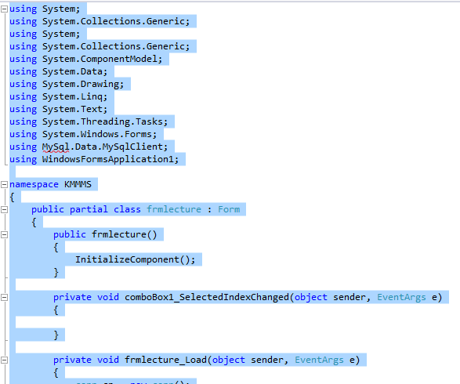

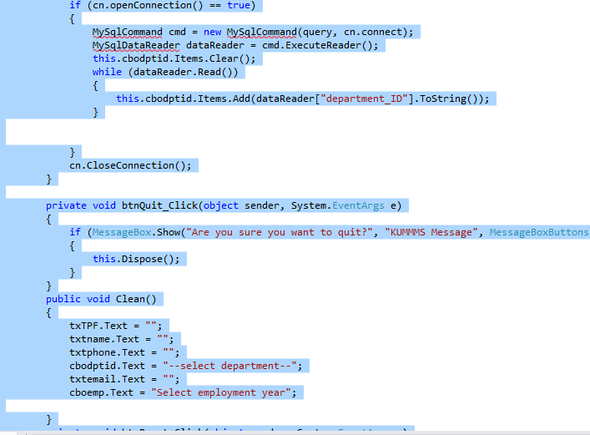

## **4.3. Testing**

## Testing is the process of executing the programs with the intention of finding out errors. During the process, the project is executed with set of test and the output of the system is evaluated to determine if the project is performing as expected. Testing makes a logical assumption that if all the parts of the module are correct then the goal will be successfully achieved. We did testing after completion of every coding phase. This system was tested from the very beginning and also at each step in different types of data entries.

### **4.3.1 Functional testing**

This is where the system is a black box whose behavior is determined by studying its inputs and its corresponding outputs. The main problem is to select the inputs that have a high probability of being members of a set in my case; the selection of these test cases is based on the previous studies.

### **4.3.2 Structural testing**

This type of testing has two challenges. It test failure behavior of the system circumstance that may arise through an unexpected combinations of events where the node placed on the system exceeds the maximum anticipated load. The structure of each module was checked every step.

### **4.3.3 Unit testing**

In unit testing the entire individual functions and modules were tested independently. By following this strategy all the error in coding were identified and corrected. This method was applied in combination with the white and black box testing techniques to find the errors in each module. Unit testing is normally considered an adjunct to the coding step.

# 5.0 CHAPTER FIVE

**5.1 RECOMMENDATIONS**

We managed to develop a system which can enable users create account and other services provided on the user interface. The system has administrative roles whereby the administrator can register new students’ details and lecturer details, manage data entering into the database through the system, give reports by retrieving information from the database and perform other functions on the interface.

We recommend that other modules can be added to the system and make them operative in future. Also additional mobile based capabilities should also be added in order to notify the lecturer concerned and the student affected with the problems of missing mark.

## **SHORTCOMMINGS**

The specified time of developing this system was limited of which we were to complete system where we had to borrow other time from other activities to balance the time estimated and cover each and every module of the system. We got challenges in collecting the data and also coding, especially in tracking and correcting bugs.

We also developed the system under financial constraints and learning some of the programming languages which we used.

## **CONCLUSION**

Developing this project was actually a challenging task. We learnt that it need a lot time hard working and commitment to come up with this system. We therefore encourage teamwork so that we can assist each other on the side where he or she experience problems. This is due to the effort of our friends and group members who tirelessly posed questions on how to improve our system for we had no supervisor but we tried our level best to consult where necessary from our lecturers.

The process of developing the system started by preparing a project proposal which showed the need for implementing user authentication of the system.

Finally, working on this project has been a great experience hence aiming to reach higher heights using that experience.

**Reference.**

1. Williams, Mickey (2002), *'Microsoft Visual C# .NET'*, Redmond, Wash.: Microsoft Corporation.
2. Martin, Tony; Selly, Dominic (2002), *'Visual Basic .NET At Work: Building 10* *Enterprise Projects'*, New York John Wiley & Sons, Inc.